**2 – Requirement Description and elicitation**

**What are requirements:**  
The hardest single part of building a software system is deciding precisely what to build. No other part of the work so cripples the resulting system if done wrong. No other part is more difficult to rectify later.  
  
Exact statement of the particular needs to be satisfied, or essential characteristics that a customer requires and which a vendor must deliver.  
  
**› Specify what the system should do – not how**  
  
For **customers** it is a specification of the product that will be delivered, a contract  
For **managers** it can be used as a basis for scheduling and measuring progress   
For the **software designers** it provides a specification of what to design   
For **coders** it defines the range of acceptable implementations and the outputs that must be produced For **quality assurance personnel** it is used for validation, test planning, and verification

**Requirement specifications:**  
› Correct – specifying something actually needed   
› Unambiguous – only one interpretation   
› Complete – includes all significant requirements   
› Consistent – no requirements conflict   
› Verifiable – all requirements can be verified   
› Modifiable – changes can easily be made to the requirements   
› Traceable – the origin of each requirement is clear

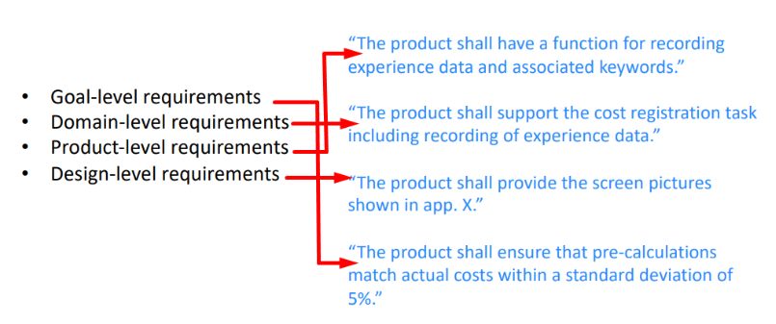 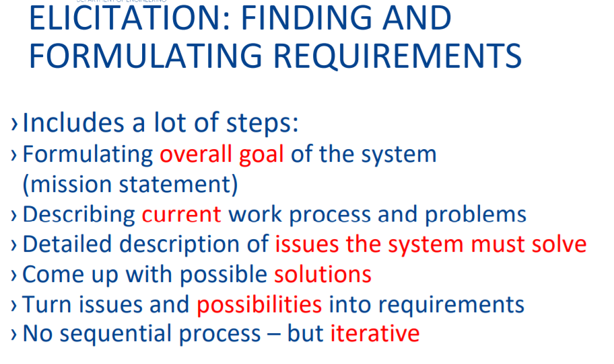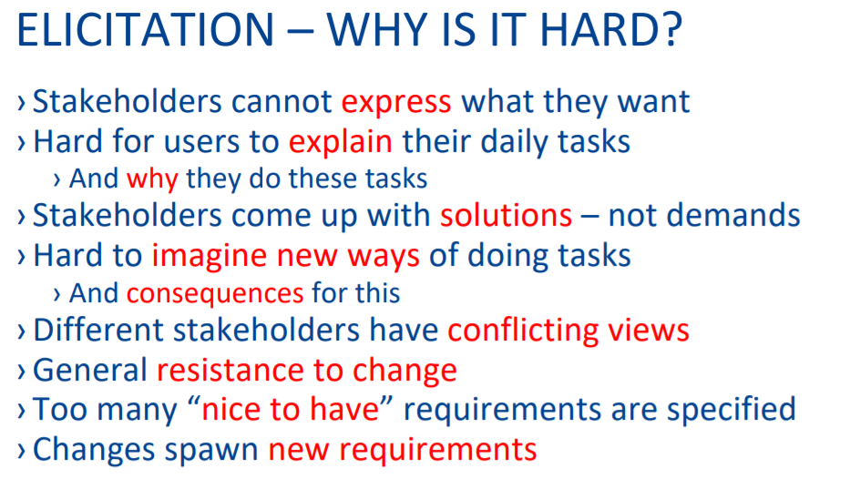

**Who are the stakeholders?**   
› A paying customer   
› Users of the current system   
› Domain experts   
› Market researchers   
› Lawyers or auditors, legislation   
› Software engineers  
  
Elitication techniques  
Observations  
User interview  
Questionnaires  
Brainstrom  
Focus group